**STEPS TO EXECUTE THIS APPLICATION SUCCESSFULLY**

1. There are two folders that make up this project (frontend and backend)
2. Install the backend first because the front-end depends on it.
3. Download and install xampp, node and composer
4. Use composer to create a laravel project
5. Copy the backend folder to the root directory of your server e.g htdocs/wamp
6. Start the server with Laravel Artisan command

**php artisan serve**

1. Install **Node JS**
2. Install the Angular CLI using

**npm install -g @angular/cli**

1. Create folder “mgf” inside the C:/ or D:/ drive
2. Copy the mgf-contact-app into the mgf folder
3. Open the mgf-contact-app in vscode
4. Go to terminal menu, create a new terminal

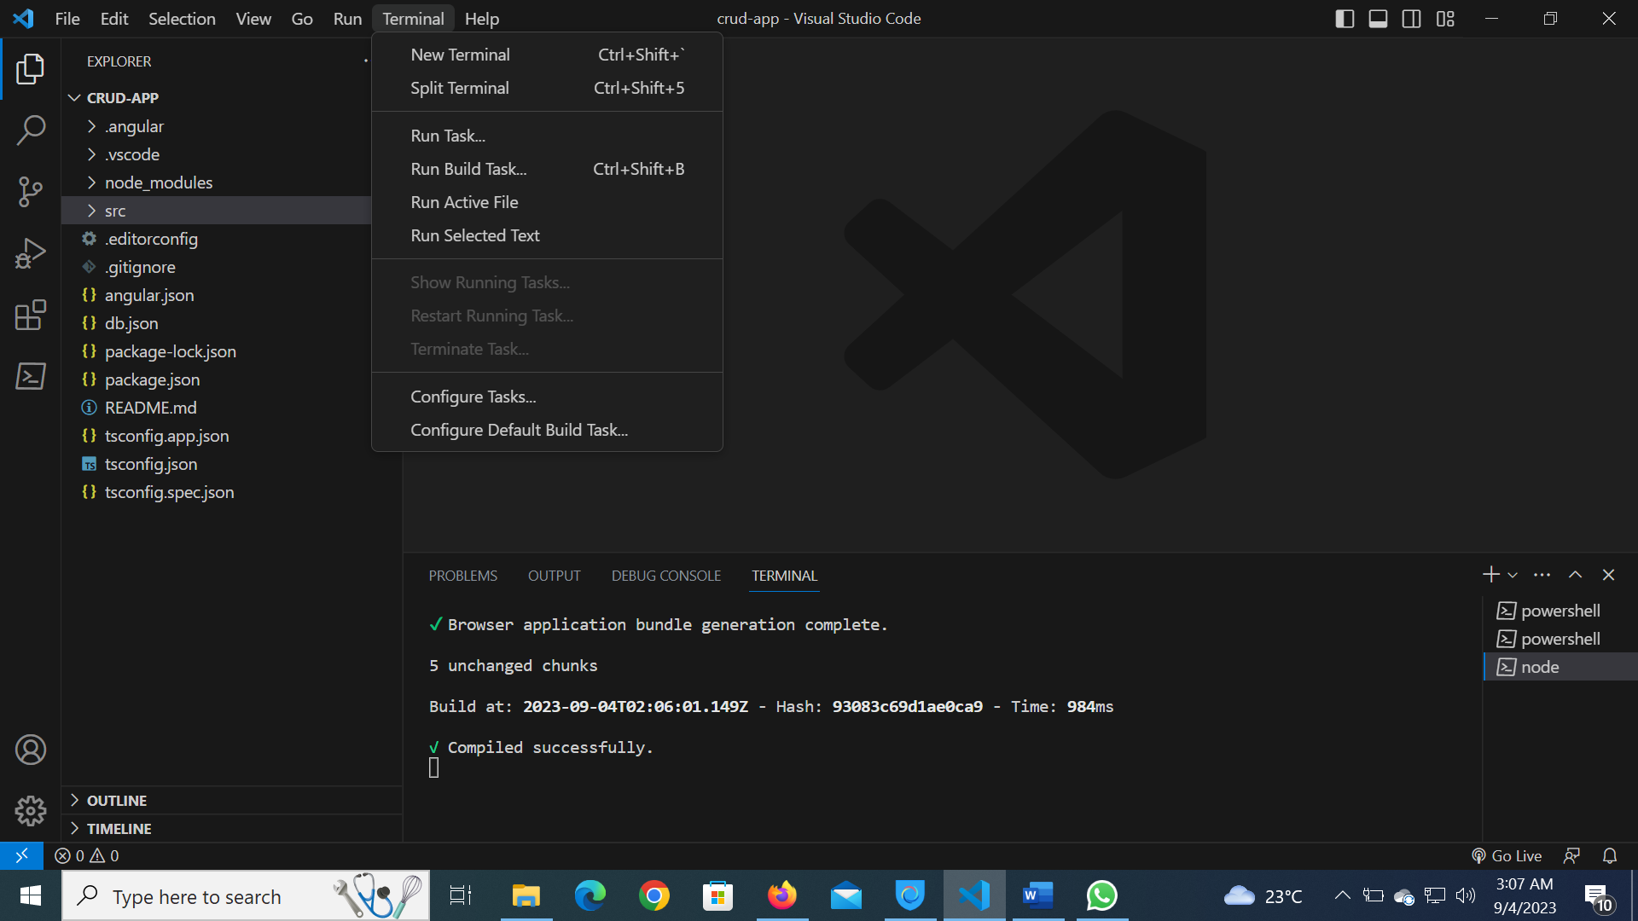

1. In the new terminal, launch the application by typing the command below:

ng serve -o

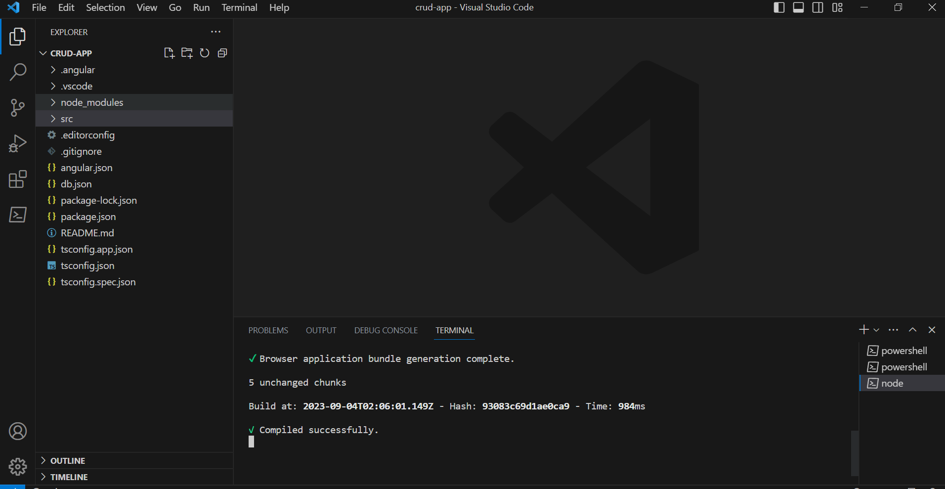

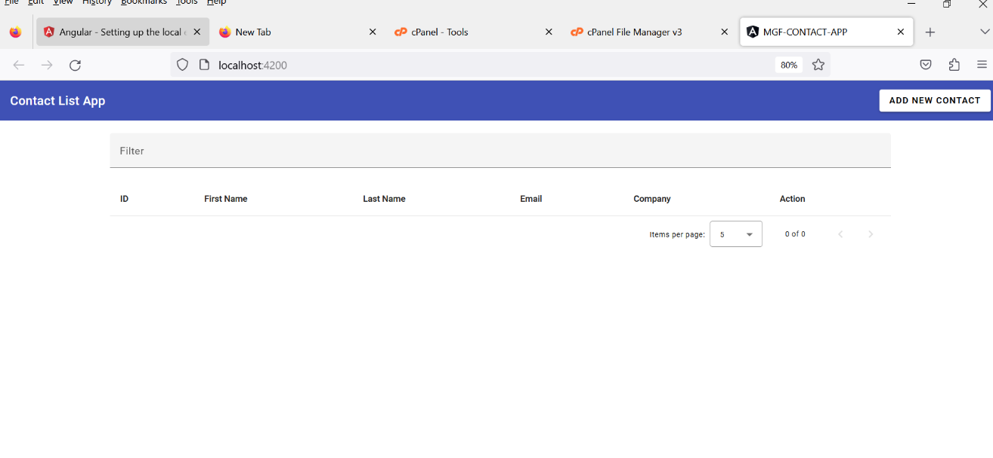 14.The application launches but with out the data

1. Open a new terminal and run the following command to start the JSON data server

JSON-server --watch db.json

**Unit Testing Interfaces**

1. This is the displayed contact

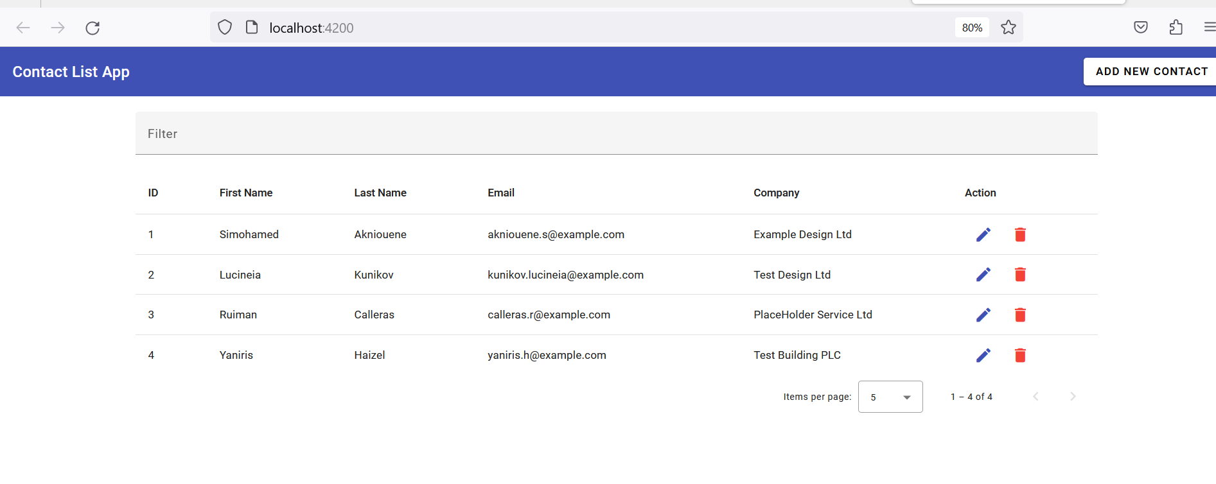

1. **Here is a view that indicates that sorting and Filtering was implemented**

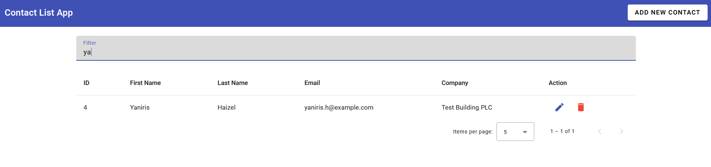

1. **A Form to add a new contact**

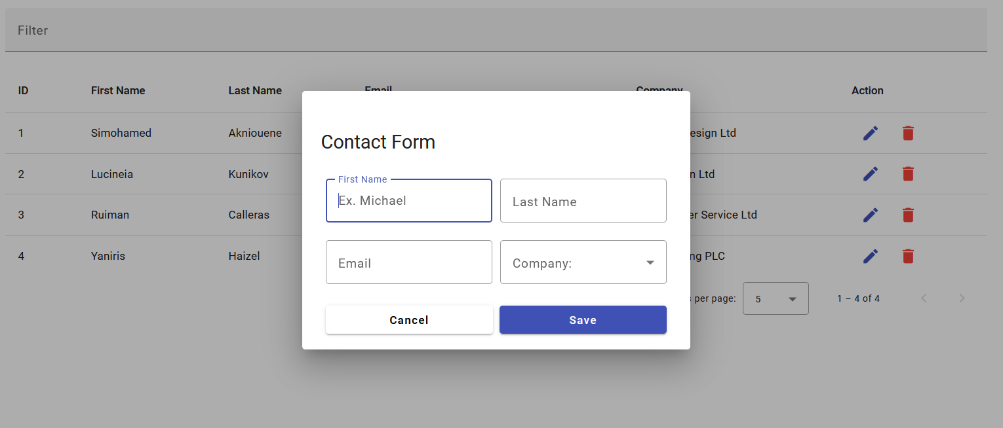

1. **A form to edit an existing contact**

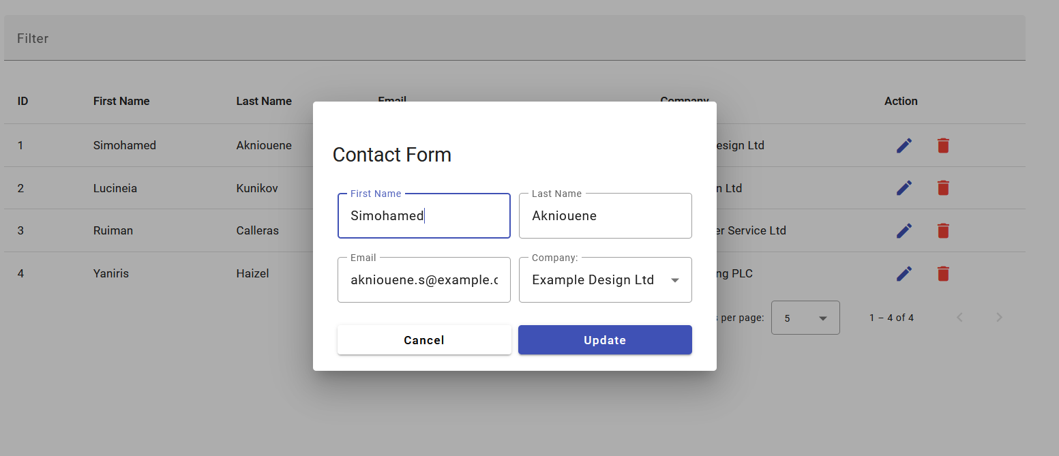

1. Ability to soft delete a contact

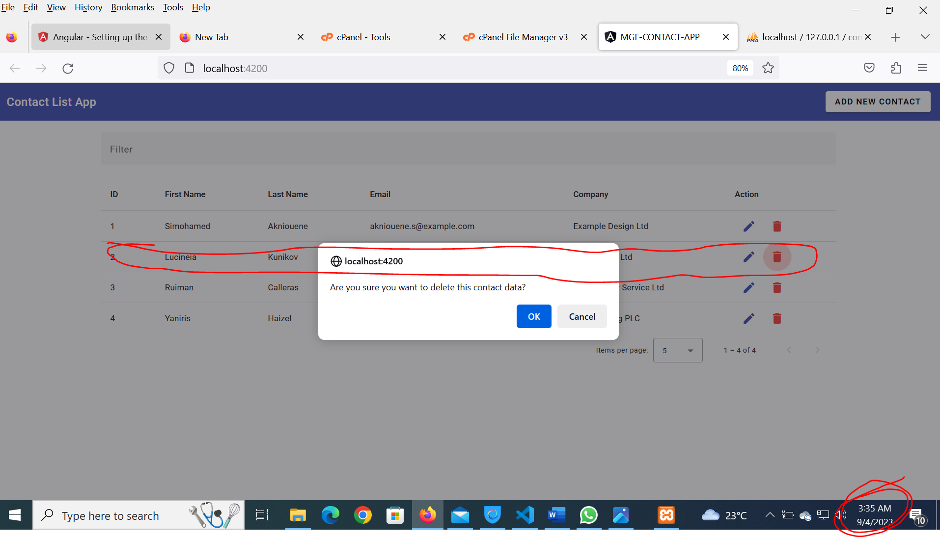

This record was deleted by 09/04/2023 3:36:00 am. Confirm from the Operating time system as marked read.

After deleting it shows here in the interface, it persists in the database

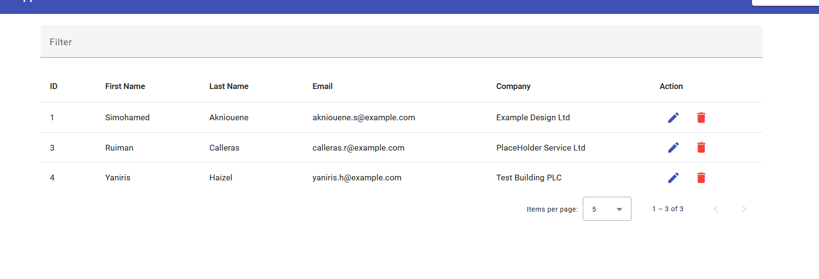

It is deleted from the interface but remain in the database

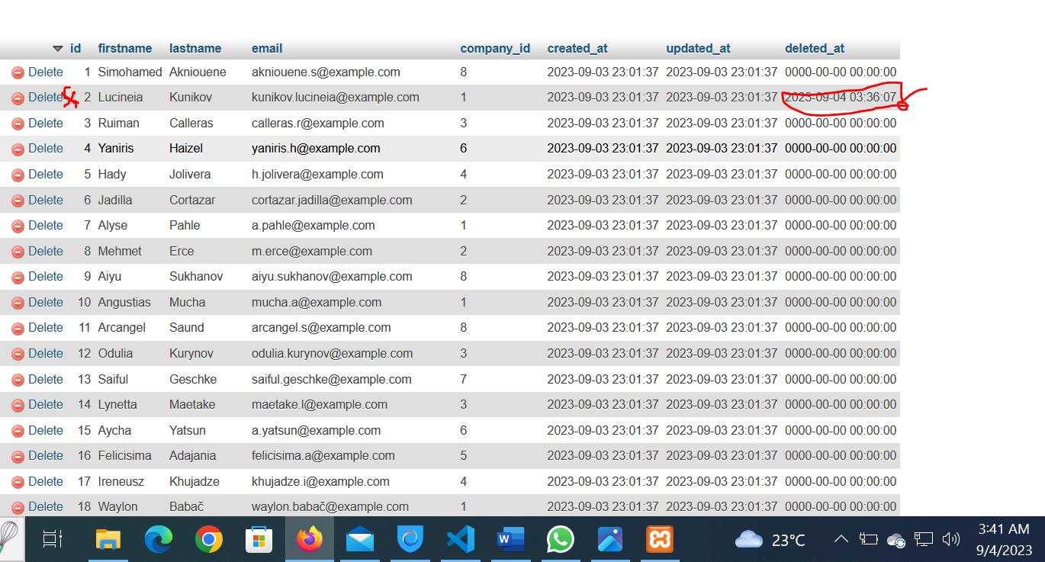

1. A report to show the number of contacts

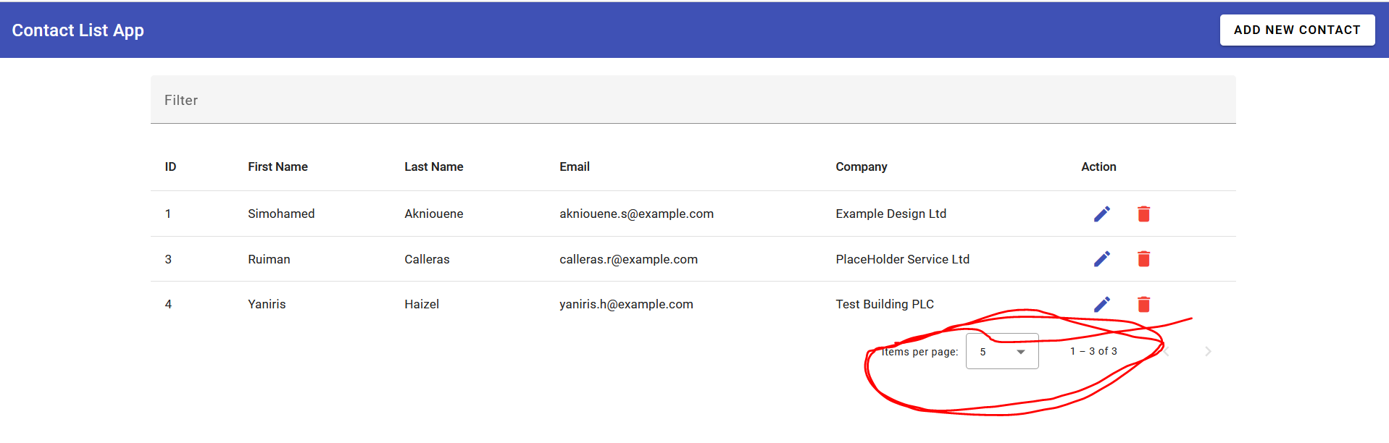

The pagination Module serves as he report